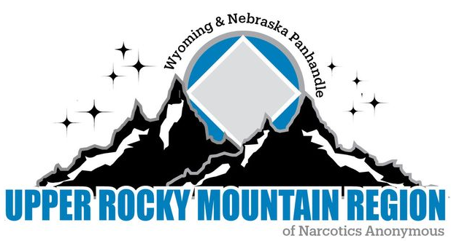

**URMR Business Meeting Minutes**

**June 1st, 2024**

**Begin meeting with Serenity Prayer.**

**Readings:**

*12 Traditions: Casey

*12 Concepts: Derrick

*Service Prayer: Dave D

**Clean time recognition since our last meeting:**

**Derrick 5 years, April 9 years, Dave W 4 years, Heather 18 months, Ron 9 months.**

**Roll Call:**

Chair: Dave W: Present

Vice Chair: Dave D: Present

Treasurer: Jenni W.: Present

Secretary: April R.: Present

Regional Delegate: Shawn S. Absent with report

Alternate Delegate: Ben H. Present

Web Servant: Interim Dave W. Present

H&I Chair: Reno W. Present

Convention Chair XXIV (24) Johnny L. Absent with report

**Regional Committee Members:**

Central Basin Area: Zack present

Central WY: Chip present

Freedom Seekers: Casey present

Wyo-Braska: Absent with report

Wyoming Western: Derrick present

**Other Guests: Heather, Katie, Ron**

**Do we have a quorum to conduct business? Yes**

**Do we have a quorum to conduct business (2/3 Voting Members Roberts Rules)? Yes**

**Number of voting members that equals 90% (8 voting members) = 7 90%**

**Approval of Previous Minutes= Roberts Rules Article V Section 7. Dave D motions to approve minutes, Casey seconds. All in favor**

**Reports:**

Chair Report attached

Vice Chair: Report attached

Treasurer: Report attached

Regional Delegate: Report attached

Alternate Delegate: Report attached

Web Servant: This is an open position. Dave W is keeping the website updated and asks that we send word documents instead of PDF for any flyers that we want put on the website.

H&I Chair: Report attached. It was brought up in the H&I recept report had 2 special edition Spiritual Principle A Day were ordered by mistake for the DOC. Treasurer and H&I chair will reach out to NA.org and see if the mistake can be fixed before shipment.

Convention XXIV: Report attached

**RCM Reports:**

Central Basin Area: Report attached

Central Wyoming Area: Report attached

Freedom Seekers Area: Report attached

Wyo-Braska Area: Report attached

Wyoming Western Area: Report attached

**AD-HOC**

None

**Serenity Break: 2:45-3:00**

**Sharing Session:**

**\***Does the regional body have specific workshop topics they would like the delegate team to cover.

Gender Neutral topics

Inmate Correspondence

**\***Wyo-Braska Area is on the verge of folding. Is there something the region can do to help prevent the dissolvement of this area.

* There is not much we can do since the decision is being made in a week.

* Make ourselves available to support.

**Old Business:**

**\*** Inmate Correspondence/ do the areas have an interest and if so how does the region move forward. Yes there is an interest.

Dave received another letter from an inmate in Worland. Committee agrees that we need an ADHOC for Behind the walls as well as reaching out to others that do behind the walls sponsorship to get information.

Derrick proposes that Dave W be the ADHOC chair of Behind the Walls. Dave accepts. All in favor.

* Were we able to get a quote on compiling the archives and have any missing archives been found. Johnny had one binder done for $250.00. A quote for the remaining was $1,500. The total is $1,750.00. Johnny was waiting on director from the area before moving forward. Reno motions to approve $1,750.00 to get the project to digitize the archives. Jenny seconds the motion. Motion passes with 8 yes and 1 no.

*Zoom options for interested members

No interest at this time

**New Business:**

**\* Do we want to move the Region meeting from October to November on account of the convention being moved to September. Discussion tabled.**

**\* Reno brought up discussion about having an Alternate H&I chair for rotation of service. The Alternate would need to meet criteria from the DOC as well as be involved and approved with the DOC. This could be made possible through his committee. He will come back with nominations and suggested guidelines.**

**Elections per guidelines:**

Chair: Casey nominates Dave D. Dave accepts. Dave qualifies self. Dave leaves room for discussion. All in favor.

Vice chair: There were no nominations. Johnny is interested but was unable to be here today.

Web-Servant: Reno nominates Dave W. Jenni seconds the motion. Dave accepts and qualifies self. Dave leaves the room for discussion. All in favor.

MMXXV Convention Chair: Wyoming Western nominates Derrick S. Derrick Qualifies self. All in favor.

Treasurer: Jenny was asked if she is willing to continue. Jenny accepts. All in favor

Secretary: April was asked if she is wiling to continue. April accepts. All in favor

**Money Matters:**

**Dave W $189.00 for travel**

**Shawn $425.00 for zonal forum**

**Johnny $1,750.00 for archives**

**Jenni $85.00 for travel**

**Ben $250.00 for zonal forum, $90.00 for travel, and $30.00 for coffee and donuts.**

**Next Meeting: Riverton**

**. Where? 2020 N. Federal Blvd**