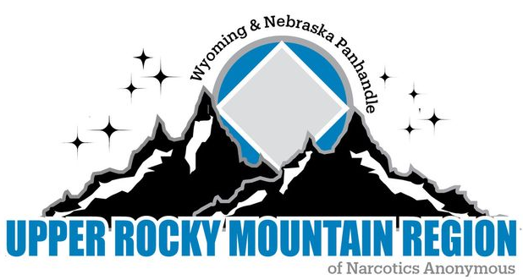

**URMR Business Meeting Minutes**

**August 3, 2024**

**Begin meeting with Serenity Prayer.**

**Readings:**

*12 Traditions: Katie

*12 Concepts: Chase

*Service Prayer: Dave W

**Clean time recognition since our last meeting:**

**Casey 2 years**

**Roll Call:**

Chair: Dave D: Present

Vice Chair: Open position

Treasurer: Jenni W.: Present

Secretary: April R.: Present

Regional Delegate: Shawn S. Absent

Alternate Delegate: Ben H. Present

Web Servant: Dave W. Present

H&I Chair: Reno W. Present

Convention Chair XXIV (24) Johnny L. Present

Convention Chair XXV (25) Derrick S. present

**Regional Committee Members:**

Central Basin Area: Zack present

Central WY: Chip present

Freedom Seekers: Casey present

Wyo-Braska: —------------------------

Wyoming Western: Derrick present

**Other Guests:**

**Alaina, Dan W, Danielle S, Chase G**

**Do we have a quorum to conduct business? Yes**

**Do we have a quorum to conduct business (2/3 Voting Members Roberts Rules)? Yes**

**Number of voting members that equals 90% (8 voting members) = 7 90%**

**Approval of Previous Minutes= Roberts Rules Article V Section 7.**

**Reports:**

Chair Report attached

Vice Chair: Open position

Treasurer: Report attached

Regional Delegate: Absent without report

Alternate Delegate: Report attached

Web Servant: Report attached

H&I Chair: Report attached.

**RCM Reports:**

Central Basin Area: Report attached

Central Wyoming Area: Report attached

Freedom Seekers Area: Report attached

Wyo-Braska Area: Report attached

Wyoming Western Area: Report attached

**AD-HOC**

**Sponsorship behind the walls. Next AD-HOC meeting is September 8, 2024 at 7pm.**

**Serenity Break: 2:07-2:15**

**Sharing Session:**

**Dave W proposes that we explore the idea of removing CBDM from the voting process. Moved to new business.**

**Old Business:**

**\*What is the current status on the archives being updated to digital archives?**

**It is paid for and in process.**

**\*The Alternate H&I chair position. What does this look like?**

**The guidelines would look a lot like the H&I chair positions guidelines. Reno has been discussing at his zoom meetings but attendance has been low so he needing more time for more discussion and will have more information to bring back to the Region in February.**

**\*Did the RCM’s bring back the idea of bridge the gap and was there interest?**

**There was some interest and others do not think we should take that on. Some want more information.**

**Bridging the Gap is an AA H&I effort. Individuals that are in treatment centers are given blue cards to fill out for AA if they would like a phone call and someone to go to their first meeting with when released. The individual puts their name and release date on the blue card as well as a phone number to reach them. They are seeing that a lot of the individuals are wanting NA or writing on the blue cards that they would like NA.**

**Lots of discussion followed. Suggestions were to make sure the treatment centers have regional meeting list at their location. Can that area take NA meetings into that treatment center.**

**Discussion tabled, take back to the areas and bring back to region in October.**

**New Business:**

**\*H&I literature budget 2025**

**Reno requested $1813.94 to bring the balance back up to $3000.00. Dave proposed that we redistribute $1813.94 to replenish the H&I efforts and revisit next August. Chip seconds. All in favor.**

**\*What are we storing on the digital archives from this point forward?**

**Tabled until October. All convention totes were handed over to 2025 convention chair today except for the drive.**

**\*Dave W proposes that we explore the idea of removing CBDM from the voting process. Tabled.**

**\*Convention bank account.**

**Upper Rocky Mountain Regional Service Committee has approved these changes to the Convention bank account: Removing Sarah Bailey and Jody Ray. Adding Derrick Sheffield. Removing John Leiker.**

**\*Elections for Vice Chair of Region.**

**Zach nominates Johnny**

**Johnny does not accept.**

**No other nominations were made.**

**Money Matters:**

**Dave W: $190.00 for travel**

**Jenni $85.00 for travel**

**Ben $23.00 for supplies and $90.00 for travel**

**Next Meeting: October 5,2024 in Riverton**

**Where? 2020 N. Federal Blvd**